ENES 100

Section 0601

Milestone 3

Team STS - Chemical

Table of Contents

|  |  |
| --- | --- |
| Page |  |
| 2 | Team contributions |
| 3 | Executive Summary |
| 4 | Introduction |
| 5-6 | Design: Structure |
| 7-11 | Design: Propulsion |
| 12 | Design: OSV Mission |
| 13-15 | Design: Power |
| 16 | Design: Sensors and actuators, Control algorithms |
| 17 | Design: Control Algorithms |
| 18-22 | Preliminary Design Details |
| 23 | Bill of materials |
| 24 | Gantt chart |
| 25 | Construction plans and anticipated difficulties |

Team contributions

John Murdock

Stephen Waak

Eliav Winton

Spencer Mical

Kenneth Daniel

Isaac Lee

Michael Tao

Executive Summary

Our team has designed a vehicle to carry out the chemical neutralization of a pool of water in a sandy terrain. The OSV must fit within a 350mm x 350mm footprint. Overall mass must not exceed 3kg and overall cost of the OSV can be at most $350. With these constraints in mind, we have designed an OSV with four wheels and a lowering platform which will drop into the pool of water to carry out its mission.

For mobility, we have a four wheeled footprint driven by a chain and sprocket. Motors will be mounted above the base of the platform to avoid impacting the pool of water. This will keep the motors safe from the acid pool and leave enough clearance for the bottom. Through control algorithms and sensors, the OSV will navigate autonomously to the pool while avoiding obstacles along the way.

Once the OSV has driven over the pool, it will lower a platform to carry out its mission objectives which include taking a sample, transmitting the pool’s pH, and neutralizing the pool.

Introduction

To fulfill the chemical mission objectives of measuring the pH of a pool, taking a sample, and neutralizing the pool, team STS has designed an OSV that can accomplish these tasks. Locomotion is enabled with four planetary geared motors running at 12v. Each of these motors is mounted atop a wooden base which will serve as the platform for all electronics including microcontroller, motor driver, batteries, and mission specific equipment. Four wheels mounted underneath the platform are connected to sprockets and will be driven through chain by the drive motors. This is to ensure that there is enough clearance beneath the OSV to drive over the pool. Drive motors are driven by a 12v NiMh 2200mAh battery, while microcontroller logic will use a separate 7.2v NiMH 2200mAh battery.

In moving to the mission site, the OSV will navigate using information provided through the APC220, a radio communication module. For obstacle detection, three ultrasonic sensors will be mounted on the front of the OSV so it can detect obstacles in a 45 degree cone in front of it. Through control algorithms, it will avoid obstacles while navigating to the site by determining any obstacles ahead of it and where they are based on proximity.

Once the OSV navigates to the mission site, it will deploy a platform with instruments used to fulfill mission objectives. This platform is held in the center of the OSV and will be further described in technical drawings. On this platform are the pH meter, a pump, and two tubes used to dispense neutralizer, and extract a sample. First, this platform will lower using a smaller geared motor. Then, a sample will be drawn by releasing a spring loaded syringe. Simultaneously, the pH will be read and transmitted back to base through the APC220. Once the base mission objectives are fulfilled, it will then begin dispensing neutralizer. The rate at which the neutralizer is dispensed will be proportional to the difference between desired and actual pH. During this period, the pump will be powered to agitate the solution, thus accelerating the neutralization process and allowing for a more accurate measurement. Once the pool is within acceptable pH ranges, the OSV will have completed all objectives.

Design Details

**Structure**

The O.S.V. is approximated to be constructed at the full 350 mm by 350 mm and then sanded down to allow for a safe margin. The O.S.V. will feature a wooden base that spans this square, and on this base will be the electronics for locomotion and mission specific hardware. Electronics will be secured to the base with screws where possible and mounting brackets if needed. Any 3d printed parts will be secured using wood glue after properly scoring both contact surfaces to allow for proper adhesion.

Our wheels will be 4-inch diameter rubber tires mounted upon 3d printed wheel inserts. These wheels feature small indentations which will help the wheel grip on to the sand better, and they will be attached to sprockets. The motors will then drive the wheels through a chain. We will not use suspension because of cost and complexity.

The O.S.V. has a box-like structure. The main body platform is a large square. On top of that, at the center of the large square, is a hollowed out cube, which houses the lifting platform and allows for its vertical movement. This platform and the supports will be 3d printed which will allow for lightweight construction yet still maintaining structural rigidity.

**Mass estimation table**

|  |  |  |  |
| --- | --- | --- | --- |
| Item | Mass (g) | Quantity | Total mass (g) |
| 12V battery | 280 | 1 | 280 |
| 7.2v battery | 125 | 1 | 125 |
| Vex Motor | 87.1 | 1 | 85.5 |
| Sprockets | 2.8 | 8 | 22.4 |
| Base Solution | 150 | 1 | 150 |
| Wooden base | 400 | 1 | 400 |
| Pump | 50 | 1 | 50 |
| pH monitor | 20 | 1 | 20 |
| Lifting Platform | 33.8 | 1 | 33.8 |
| Arduino | 20 | 1 | 20 |
| Wheels | 10 | 4 | 400 |
| Motor | 160 | 4 | 640 |
| Platform counterbalance | 50 | 5 | 250 |
|  |  |  |  |
| **Total** |  |  | **2565.4** |

**Propulsion**

*Figure 1. Torque equilibrium. Resultant of and points directly at wheel center*

*At constant velocity,*

*Figure 2. Horizontal forces equilibrium. , , , are internal forces.*

At stall,

X:

Y:

*Torque from contact point of front wheels*

𝜏

*Figure 3. Equilibrium equations for OSV stalling on an incline.*

*Equation 1. Stall torque in one rear wheel on an incline.*

*Equation 2. Tractive effort and torque maximum to avoid digging into the sand.*

*Figure 4. Motor Torque vs RPM found by converting the motor’s data sheet using a reductioin ratio of 100 and an efficiency of 60%.*

It was decided that the wheels must be 3d printed because the design calls for a very narrow range of dimensions that could not be fulfilled by any wheels on the market. The wheel dimensions were chosen to allow the OSV to clear the pool of water and take the platform above the water. The diameter was calculated with the height of the pool in mind, and the width was calculated with the dimensions of the OSV versus the diameter of the pool in mind. The width was optimized for sliding over sand while still allowing the OSV to drive over the pool. It was decided that the diameter of the wheels would be 107mm and the width 44mm. The wheels will be placed 11.15cm away from the center of mass, measured in the direction of motion, and 1cm inward from the edge of the OSV to allow for the chain and sprocket system. They will be housed in two-sided wheel housings to hold them in the same orientation.

The torque calculations were derived with the models depicted in figures 1, 2, and 3. Equation 1 was used with the following dimensions: a radius *r* of 5.35cm, a width *w* of 4.4cm, a diameter *d* of 10.7cm, a height *h* of the center of mass of 11cm, a mass *m* of 3kg, an acceleration *g* due to gravity of 9.8, an angle of incline *ϴ* of 35°, and a length ℓ between the center of mass and center of a wheel of 11.15cm. Using this equation, the minimum torque per wheel required was determined to be 22Ncm. Using equation 2, the maximum torque that could be output to avoid digging into the sand was found to be 27.5Ncm at 0°. Only the scenario with a 0° incline was considered because it was determined that the wheels digging on an incline would not be a problem. The digging would reduce the incline since the front wheels would begin to dig the sand before the rear wheels. Using these parameters, a 12V motor with a rated torque of 46Ncm was chosen. Each wheel would have its own motor. The motor has a variable torque and angular velocity. Since the maximum torque required for OSV operation is lower than the torque at which the wheels begin digging the sand, it was determined that this motor would always operate under the torque for digging, yet always be able to provide enough torque to overcome the sand and any inclines of the sand.

The drive train was designed with the platform mechanism in mind. It was determined that the motors and wheels must be separated so that the motors would not be in the way of the OSV successfully getting over the pool. To achieve this, the four motors would be placed on the base of the OSV and drive the wheels using a system of chains and sprockets. The sprockets would be sized at around a 1:1 ratio initially but, because of the need to reduce OSV velocity, may end up being around a 1:3 ratio. The chains and sprockets would be oriented to the outside of the OSV, so that there will be maximum clearance on the inside to fit the pool between the wheels. Using the torque vs. RPM graph in figure 4 and a wheel radius of 5.35cm, the range was obtained for OSV velocity for between operation at 35° and at 0°, with 1:1 sprockets. With a wheel sprocket that is 3 times wider than the motor sprocket, a theoretical mechanical advantage of 3 is introduced. This means that the torque output is 3 times the torque input and the angular velocity output is one-third the angular velocity input. The wheel would still need the same torque to overcome its resistance, so the motor would output much less torque. This would increase the angular velocity of the motor because angular velocity is inversely proportional to torque. However, as seen in figure 4, reducing the torque by a third does not increase angular velocity threefold because the two quantities are related by a constant. Overall, this design is expected to reduce the angular velocity, and thus the OSV velocity, by approximately 50%, while lightening up on motor current draw due to the lower motor torque requirement.

The steering system will be differential steering and not require any servos. It will turn by adjusting the relative speeds of the different wheels. Pulse-width modulation will be used to lower the angular velocity of certain motors. This can be performed at the motor bridge and be controlled by the Arduino. PWM can be used to proportionally lower the effective current and voltage that is applied to the motor. The motor will then draw more current at the battery to produce the same torque, but its voltage will be lower and be constant. Torque is directly proportional to current because current produces the magnetic field inside the motor that drives the motor shaft. However, angular velocity is directly proportional to voltage because motor voltage is used to overcome the counter-electromotive force produced by the rotor spinning through the motor’s magnetic field. The motors that need to slow down will be fed lower voltage and therefore output a lower angular velocity at the cost of requiring higher current draw to produce the same torque. However, this will not impact battery capacity requirements because the increased current draw is balanced out by the <100% duty cycle, and total power draw will be roughly the same.

**OSV Mission**

For our chemical neutralization mission, our primary objective is finding and neutralizing a pool of water within a five minute window. The OSV is required to navigate within 250 millimeters of a polluted water pool with the water being between 650 and 850 milliliters and the acidity being between 2 pH and 5 pH. Once it reaches the pool we must measure the pH level of the pool and report back to command the pH level to within 0.3 units. After testing the pH level it must then extract a 10-15 milliliter sample of the polluted water. Once we have successfully collected the sample of water we can then begin to neutralize the pool and bring the pH level back to between 6 and 8 and report the newly adjusted pH to the command.

To navigate to the pool, the OSV will use distance sensors and differential steering to navigate around the obstacles. After the obstacles are cleared, the OSV will drive to the coordinates of the pool. Once over the pool, the OSV will lower the inner platform into the pool. From here it will extract the sample of the polluted water, measure the pH of the pool, and send the pH reading back to base. After this part is complete, the OSV will dispense the fully saturated sodium bicarbonate solution until the pH of the pool reaches 6 using a closed feedback loop. While the base is being dispensed, the pump will be agitating the pool to mix in the base. Once the pH meter reads a pH within the range of 6 to 8, the OSV will stop dispensing base and will report the measured pH to base.

**Power**

For our power system, we used two separate batteries. The battery that we will be using to power the Romeo Board is a 7.2V 2200mAh NiMH battery. This will provide power for all mission specific hardware. The battery that is used to power the wheel motors is a 12V 2200mAh NiMH battery. These batteries were chosen because they are able to supply power within the operational limits of the electronics necessary for function and sustain that power for a long enough time.

The 12V battery will connect to the H-bridge that connects to the four drive motors. Calculating the current draw of the four motors used to power the wheels in the OSV is dependent on the amount of torque that is required in each of the wheels. As previously stated, the amount of torque required will depend on the angle of the wheel the motor is attached to with respect to ground level. Once this is known, determining the current can be done by using the equation:

*Equation 3. Current draw at a given motor torque*

In this equation, is the current draw, is the motor torque constant which is equal to 11.78mA/Ncm or the max current of 530mA divided by the stall torque of 45Ncm, τ is the torque, and is the no load current of 150mA. This allows us to determine the range of currents that are possible. Based on the previous torque calculations:

Minimum torque required: 14.3Ncm

Maximum torque required: 22.2Ncm

And using equation 3 to find the minimum and maximum current draws:

Minimum motor current draw: 318mA

Maximum motor current draw: 411mA.

Because there are four separate motors,

Minimum 12v battery draw = 1272mA

Maximum 12v battery draw = 1644mA

Taking these numbers into consideration, we found a battery that can sustain this current draw. Capacity is given by the equation:

Thus, by substituting in battery capacity, min and max current draws, we calculate that:

Minimum battery life = 1.34 hours or 80 minutes

Maximum battery life = 1.73 hours or 104 minutes

To prevent damaging the battery, %20 of the battery capacity is reserved, and assuming maximum current draw for the entirety of the run time means that the calculated battery life is:

Battery run time = 64 minutes

As previously stated, the 7.2V battery will be used to power all the other functions on the OSV and this battery will be plugged directly into the Romeo Board. The Romeo Board will in turn be wired and connected with the various parts of the OSV to provide them power. The only exception to this will be the APC-220, which will be plugged directly into the Romeo Board. In order to determine the runtime of this battery, we had to calculate the total current that would be drawn by the various parts of the OSV that the Romeo Board is wired into. To do this we checked the data sheets for the parts for their standard current draw. We then summed these numbers up and divided them into the 2200mAh that we knew this battery would provide.

Expected battery draw of mission specific equipment

APC: 42mA

Romeo board: 300mA

3x HC-Sr04 Ultrasonic sensor: 45mA

Brushless water pump: 400mA

Lifting platform: 150mA

Vex motor (at expected torque and using Eq. 3): 1.2A

Summing up these currents yields a maximum concurrent current draw of 2.1A. If we assume that all of these components will run at full for the entire time, through Eq. 4, we yield a run time of 1.02 hours. In practice, the run time will be much higher because the components will only run for a small portion of the time the OSV is active. Specifically, during the completion of mission objectives.

**Sensors and actuators**

The OSV will receive location data including the position and orientation of the OSV, and the position of the objective through the APC220. Using this data, it will use control algorithms to avoid obstacles. The three ultrasonic range sensors are mounted on the forward facing side of the OSV. One will point directly towards where the vehicle is heading, and the other two will be off to a 45 degree angle. In this configuration, the OSV will be able to tell exactly where obstacles are in front of it. For example, if the sensor pointing 45 degrees right indicates an object approaching, the OSV knows that somewhere off to the right, there is an obstacle. A small course adjustment can be made to ensure no contact. However, if both the right pointing and forward pointing sensors indicate an obstacle, the OSV knows that the obstacle is obstructing the path more. Then, a larger correction would be made to avoid the obstacle.

One actuator will be one motor on a worm gear and rack system. This will provide adequate linear force to depress the syringe and dispense base slowly and precisely. A solenoid will be used to retract and allow a spring driven syringe to extract a set volume of fluid for sampling purposes. The final actuator is simply a motor atop the platform. When powered, it will slowly lower the platform allowing for a controlled deployment of mission hardware.

**Control Algorithm**

The proposed methods for locomotion are as follows:

turn(angle)

moveForward(x, spd)

moveBack(x, spd)

detect(sensor)

These fundamental functions will allow the OSV to move, and a more complex algorithm will implement these methods to allow the OSV to navigate precisely within its environment. For example, the OSV would first calculate the x position of the target, and turn towards that heading given its initial position. Then, it would continuously detect any obstacles along the way and make adjustments accordingly, utilizing turning, moveFoward, and moveBack if it finds itself stuck.

Once the mission site is reached, the OSV will use these methods to carry out the mission objectives:

lowerPlatform()

getSample()

readpH()

transmit(pH)

neutralize(pH)

-readpH()

-dispenseBase(mL)

-agitate(duration)

-delay(ms)

These methods are listed in order in which they will be called, and adequate time will be given to allow the hardware to make accurate measurements. For neutralization, a closed feedback loop will allow neutralization to a precise pH by continuously measuring pH, and dispensing a proportionate volume of neutralization solution. Then, it will agitate the solution to allow for a more accurate measurement, as well as accelerating the neutralization process. Once this has reached a satisfactory pH, the OSV will finally transmit the ending pH of the pool.

Preliminary Design Details

OSV Configuration:

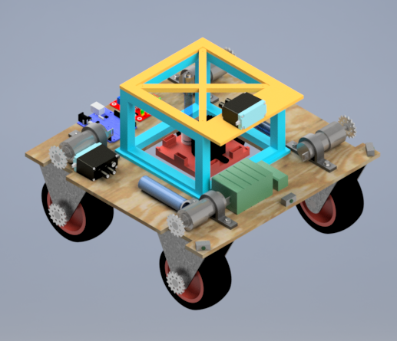

Motor Mount

Distance Sensor

Gear Sprocket

Base Syringe

Steel Wheel Mount

Romeo Board

12V DC Motor

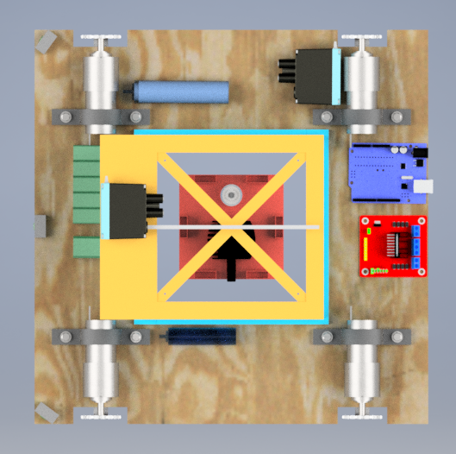

Counter Balance Slot

Agitation Pump

pH Monitor

Vex Motor With Pulley System

Base Syringe

12V and 7.2V Battery

L298 Duel H-Bridge

Sampling Syringe

Design Overview: To complete the chemical mission, this OSV is designed to maneuver about the chemical spill. Once in place, a pH monitor, agitation motor, and needed tubing will be lowered to titrate the pool.

* To maximize the allowance of error in maneuvering, this design is uses the maximum base dimension of 350x350mm and a suspension height of 127mm. To drive over the chemical spill with a diameter of 190mm, clearance space become a concern. With maximum dimensions, tolerance in navigation is permitted lessening the likelihood of the vehicle getting stuck while maneuvering over the spill.

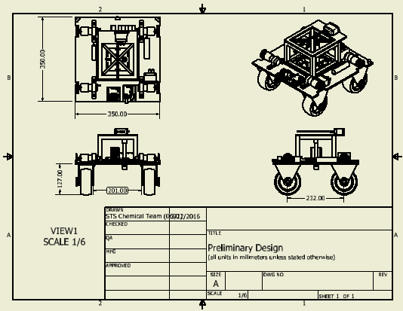

As seen above, these maximum dimensions permit approximately 11mm of clearance making navigation the largest issue in the design currently. With a varying sand depth (15-60mm) and pool rim height of 75mm it is expended that we must clear a height between 15-60mm. The OSV chassis is placed 127mm above the sand to provided additional room for error and any parts that may be included in later designs.

* Main Vehicle Chassis: Is constructed by one piece of sanded plywood with a thickness of 5/16 inches. From a precut size of 350x350mm, needed are made into the wood.
* Mission Specific, Syringes: To complete the advanced mission objectives two syringes are used. One (smaller) syringe is operated by a solenoid and springs to withdraw 12mL of water while one (larger) syringe, attached to a vex motor, is used to dispense a base solution. These syringes, as seen in the configurations are located on the main chassis. Plastic tubing connects these syringes to the lifting platform.
* Mission Specific, Lifting Platform: This platform contains a pH monitor, agitation pump, and needed syringe tubing and must be balanced to operate. The dimensions of this platform is 92.8x92.8x10mm to allow for a 75% error in navigating into the pool. Because this platform is suspended, it must have a balanced center of gravity. To accommodate error in balance counterweight slot are added. This calculation was made as follows.
  + Assumptions:
    - PH monitor mass=20g
    - Pump mass=50g
    - PH monitor is C of G located 28.15mm from the lifting platform center.
    - ThePH monitor and pump will be placed along a single axis.

Axis of moment

Calculation: Mph monitor +MPump =0 => (28.15mm)(20g)(9.8m/s2) = (Xm)(50g)(9.8m/s2) =>

X= -11.62mm

* Mission Specific, Lifting Chassis: To lift the platform, a box like chassis is used to guide strings, attached to a motor operated pulley, and balance the platform. This chassis consist of 7 subordinate parts as seen bellow.

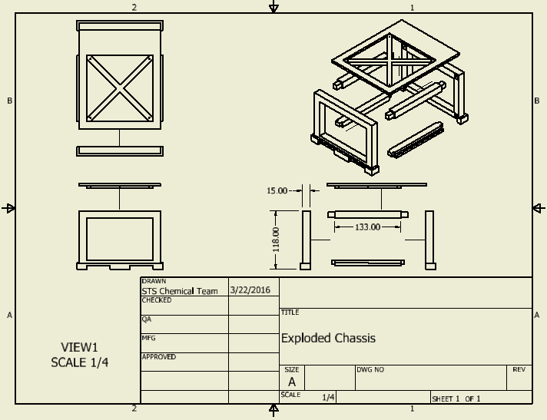

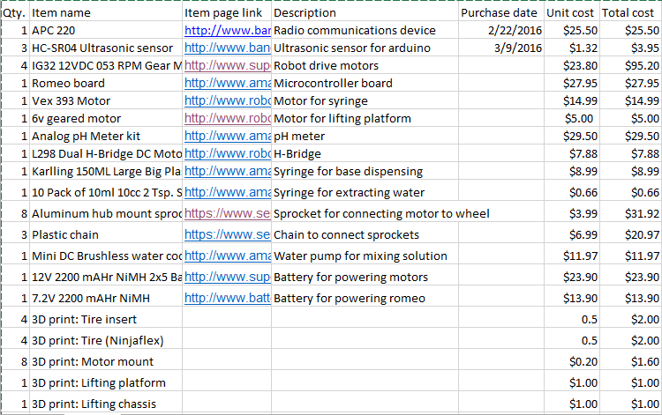Bill of Materials

Current estimated total cost: $331.88

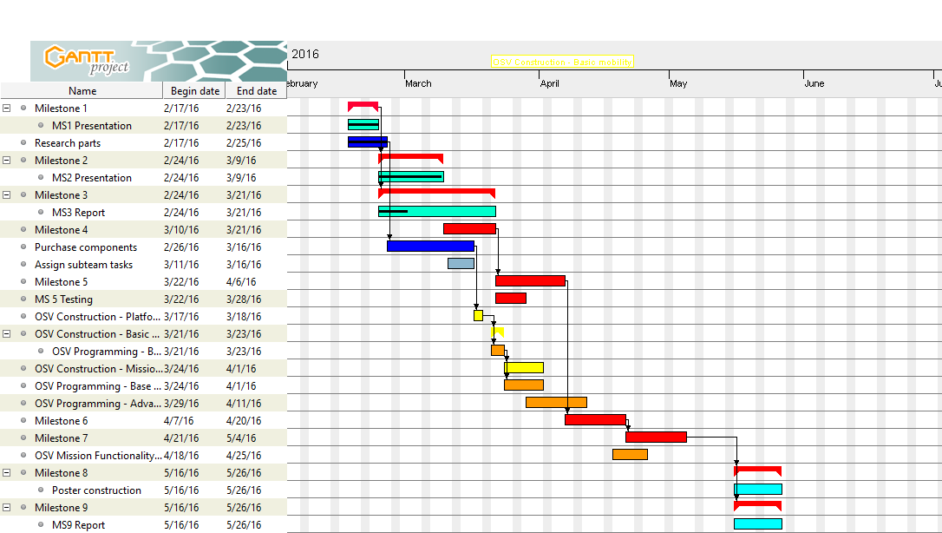Gantt Chart

Construction Plan

* Begin by constructing wooden base to specifications
* Mount motors and wheels to body
  + Compsci team will work on coding for the Romeo board
* Once motors and wheels are mounted, test mobility using basic controls
* Start constructing platform with instruments
  + After platform is constructed, the platform will be tested outside of the OSV
* Start layout of secondary mission specific electronics on base body
  + This includes sensors, H-Bridge, Arduino, and batteries
* Connect the platform to the OSV and test the mechanism to drop the platform

Anticipated difficulties

* May have trouble fitting together components
  + Solution: Have CAD team work on 3d printed parts to fit everything together
* Programming can prove to be challenging
  + Solution: Dedicate more resources to development and testing of control algorithms
* Lack of time to collaborate
  + Solution: Divide up tasks so that they can be worked on individually
* Parts malfunctioning
  + Solution: Report to leader immediately so replacements can be ordered